Project 5 Shortest Path Problem
Assigned：Nov. 19th
Due time: Dec. 3rd
Based on the result of the lab 4, program to find out the shortest path between any pair of vertices of the graph which is shown in the fig.1. Use adjacency list to implement the graph. The output of the program should be the shortest paths between any pair of vertices and the length of it as well.
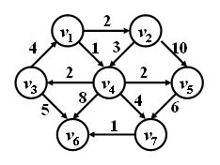
fig. 2

